|  |
| --- |
| WILDFIRE BOOK CLUB **Free books. Free coffee. Free snacks. Just RSVP!!!**  **Club meets at Gil’s Goods,**  **Livingston, MT:**  **Thursday, March 28th @ 10am**  **Thursday, April 25th @ 10am** |

|  |
| --- |
| Are you interested in learning more about wildfire? Join the club! Meet on the following dates to discuss the books:  March 28th- *The Big Burn* by Timothy Egan  April 25th- *Land on Fire* by Gary Ferguson  RSVP by February 28th so you have enough time to read your book before we meet!    Please RSVP MSU Extension 406-531-2229 |

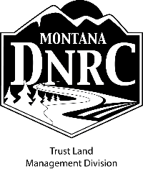

**Montana State University Extension is an ADA/EO/AA Veteran’s Preference Employer and provider of educational outreach.**