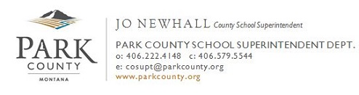

HOME SCHOOL REGISTRATION
The receipt of this by the County Superintendent of Schools about your intention to home school your children will insure compliance with Section 20-5-109 (5) MCA: Nonpublic school requirements for compulsory enrollment exemption. To qualify its students for exemption from compulsory enrollment under Section 20-5-102, MCA, a nonpublic or home school shall
(1) maintain records on pupil attendance and disease immunization and make the records available to the County Superintendent on request:
(2) shall provide the minimum aggregate hours of pupil instruction in accordance with 20-1-301 and 20-1-302;
(3) be housed in a building that complies with applicable local health and safety regulations;
(4) provide an organized course of study that includes instruction in the subjects required of public schools;
(5) in the case of home schools, shall notify the County Superintendent of Schools, of the county in which the home school is located, in each school fiscal year of the student’s attendance at the school.
An immunization form should be included if this is the first year as a home school or if changes have been made since last year.
Please contact me at 222-4148 if you have any questions.
=====================================================================
The following student(s) will be home schooled for the 2017 - 2018 school year.

Student Name Date of Birth Age Grade District of Residence
_______________________________ _________ ____ ____ ____________________

_______________________________ _________ ____ ____ ____________________

_______________________________ _________ ____ ____ ____________________

_______________________________ _________ ____ ____ ____________________

_____________________________ __________________________________
Parent or Guardian (please print or type) Signature

_______________________________ __________________________ ______ ________________
Address City State Zip

Mailing Address (if different): ___________________________________________________________

____________________________ _______________________ __________
E-mail Address Phone Date

PLEASE COMPLETE “NOTIFICATION OF OPPORTUNITY TO PARTICIPATE IN FEDERALLY FUNDED PROGRAMS” ON BACK OF THIS SHEET.

