**Still being built. Please check back later**.

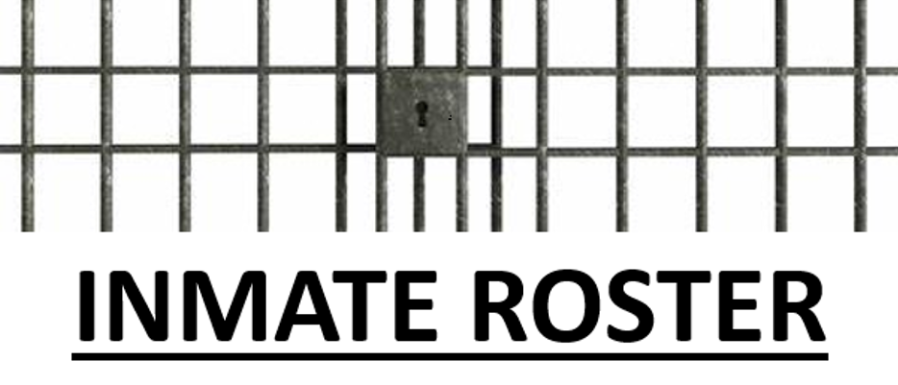

|  |  |
| --- | --- |
|  | **List of Inmates currently housed in the Park County Detention Center. Website is updated every night between midnight and 0200AM.** |

|  |  |  |
| --- | --- | --- |
| **INMATE** | **CHARGE/BOND** | **HOLDING AGENCY/ ARREST DATE** |
| Barnes, Alex | Aggravated Driving Under the Influence of Alcohol 1st Offense Release 12-29-2020 @ 2045 hours | SO/ 12-27-2020 |
| Crawford, Andrew | Felony Assault w/ Weapon  Criminal Trespass  Criminal Mischief. $30,000 Bond.  Gallatin County Justice Court Bail Bond Revocation $1,150 Bond  SCRAM prior to release. | SO / 12-18-2020 |
| Cruz, Julie | Felony Criminal Possession of Dangerous Drugs NO BOND TBA | SO/ 12-27-2020 |
| Fillion, Samantha | Felony DOC Hold. | MT DOC/ 10-26-2020 |
| Grover, Tristen | Felony Possession of Dangerous Drugs-Meth, Misdemeanor Theft $6,500 Bond- Park County  Felony Theft, Misdemeanor Theft, Criminal Mischief. $500 Bond-Sweet Grass County.  2 Yellowstone County Extra-Jurisdictional Warrants. $1,640 Bond.  Drug Patch prior to release. | SO/SGCO/YSCO 11-25-2020 |
| Lowrie, Mason | Felony Assault w/ Weapon X3  Misdemeanor Assault/Apprehension  Misdemeanor PFMA 1st  Misdemeanor Possession of Intoxicating Substance Over 18/Under 21. $15,000 Bond. SCRAM prior to release. | SO / 12-19-2020 |
| Mason, Brandon | Misdemeanor PFMA 1st. $2,500 Bond. SCRAM prior to release. | SO / 12-5-2020 |
| Schleicher, Scott | Felony DOC Hold | MT DOC / 12-12-2020 |
| Toftemark-Smith, Douglas | State of Oregon Felony Extra Jurisdictional Arrest Warrant NO BOND TBA  Misdemeanor Disorderly Conduct $185 Bond TBA  Misdemeanor Careless Driving $85 Bond TBA  Misdemeanor Assault NO BOND TBA  Misdemeanor Driving a motor vehicle while privilege to do so is Suspended or Revoked NO BOND TBA  Felony Driving Under the Influence of Alcohol 4th or Subsequent Offense NO BOND TBA | MHP/OR DOC/  12-27-2020 |

List of Inmates currently housed in other facilities.

|  |  |  |
| --- | --- | --- |
| **INMATE** | **CHARGE/BOND** | **AGENCY** |
|  | No inmates housed by other agencies for us at this time. |  |
|  |  |  |
|  |  |  |
|  |  |  |

*Disclaimer  
Information contained on the website may change without notice due to changes in the law, emergencies, and necessary changes to Park County Detention Center policies due to COVID or other circumstances.

This website is intended to assist the public in accessing public information more easily and is provided as a service to the public pursuant to Public Record laws. Park County reserves the right to discontinue this service at any time and for any reason.

This information should not be used in any manner to injure, harass, or commit a criminal act against any person or family member of a person named in the jail facility. Any such action could subject you to criminal prosecution. All persons are innocent until proven guilty in a court of law.  If errors are noted in any inmate record, the Park County Detention Center will make every attempt to verify and correct the error.