FY 2020 Park County DUI Task Force Plan
July 1, 2020 - June 30, 2021

Submitted June 25, 2020
To the State Highway Traffic Safety Bureau
Montana Department of Transportation
P.O. Box 201001
Helena, MT 59620-1001

Mission Statement
It is the mission of the Park County DUI Task Force to reduce the number of deaths and injuries due to impaired driving through education, assisting law enforcement, and community collaboration.

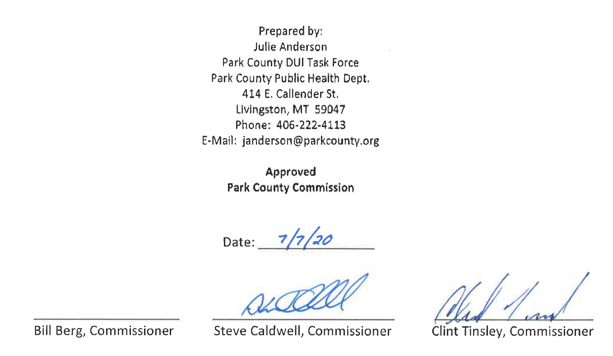

TABLE OF CONTENTS

Table of Contents 2

State Overview 3-7

Park County Overview 7-9

Program Goals & Administration 9-11

Task Force Goals:

I. Media Advocacy 11

II. Law Enforcement Support 11

III. Underage Drinking Prevention 12

IV. RASS Training 12

V. Bar Checks for Over-service 13

VI. Additional Funding 13

VII. Evaluation 14-15

Budget 16

Every day, 29 people in the United States die in motor vehicle crashes that involve an impaired driver. This is one death every 50 minutes. According to the National Highway Traffic Safety Administration, the annual costs of alcohol-related crashes totals more than $44 Billion.

State Overview

Montana is the fourth largest state in the U.S. with a land area of approximately 145,546 square miles, which includes 74,881 miles of public roads. According to the US Census Bureau, an estimated 1.062 million people reside in the state of Montana.

Motor vehicle crashes remain the leading cause of death for people from age 5 to 34 and is the leading cause of unintentional injury and death in Montana. Montana has one of the highest fatality rates in the nation for the number of deaths caused by alcohol impaired drivers per vehicle mile traveled (VMT).

• 1,011 died in crashes involving a drunk driver in Montana from 2009-2018.

• 3.4% of Montanans report driving after drinking too much in the last 30 days compared to the national average of 1.9%.

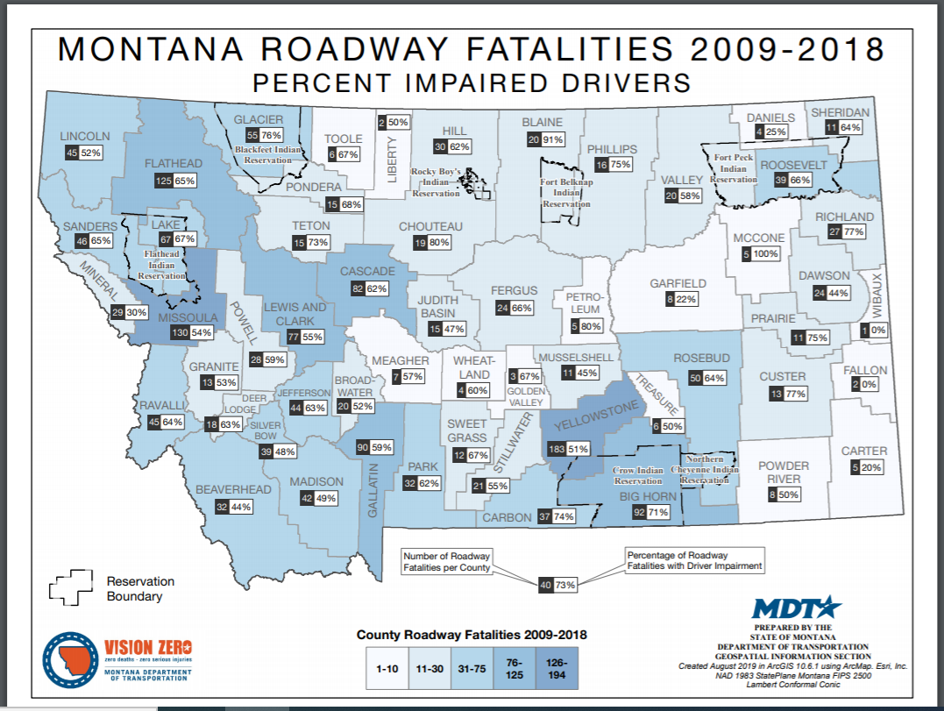

VMT (Vehicle Mile Travel) is the exposure number that appears to have the greatest influence on the amount of traffic crashes that occur in Montana. Even when crash numbers, injuries, and fatalities are held stable, gains in rates are made because of increases in exposure.

Statewide Effort and Data

The Montana Department of Transportation along with its partners and safety stakeholders across the state, are working to implement a wide range of programs to prevent and reduce impaired driving and its consequences. This approach includes strategies from the 4 E’s of safety – Engineering, Education, Enforcement, and Emergency Medical Services.

Currently, Montana’s Comprehensive Highway Safety Plan has four priority strategies to reduce impaired driving fatalities and serious injuries:

•Reduce impaired driving through improved processes and regulations
•Reduce impaired driving through enforcement
•Reduce impaired road users through prevention education
•Continue to support and build collaborative partnerships to reduce impaired driving

In 2014, Montana committed to Vision Zero – a vision of zero fatalities and zero serious injuries on Montana’s roadways. The interim goal of the program is to reduce fatalities and serious injuries by half in two decades, from 1,705 in 2007 to 852 by 2030.

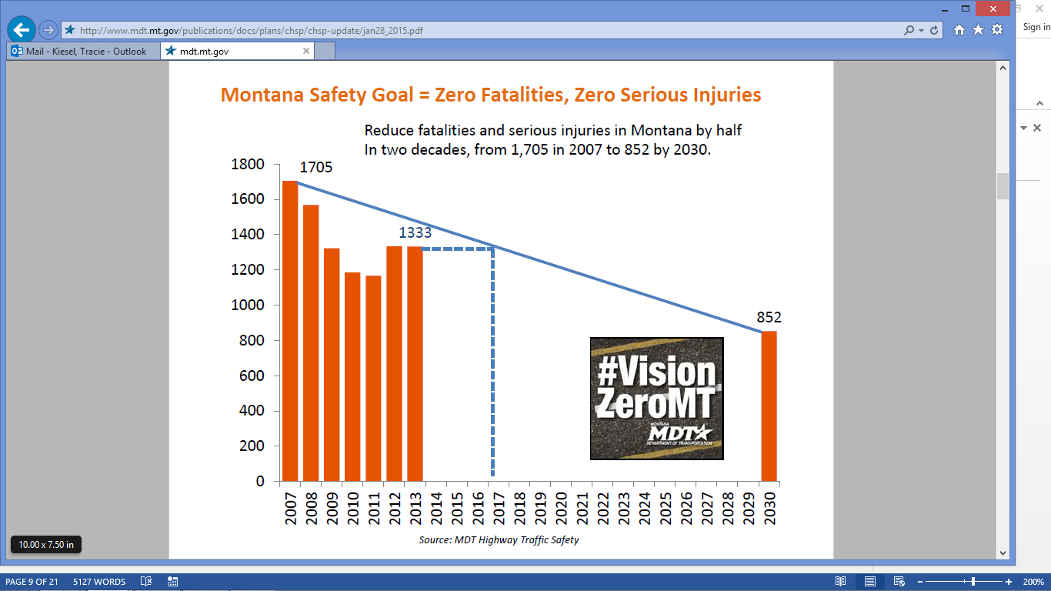

Montana is a Vision Zero state and established a goal of cutting the number of motor vehicle related fatalities and severe injuries in half by 2030. Unlike many states that have seen fatalities and serious injuries increase, the State is on track to achieve its goal by 2028, an exceptional accomplishment.

This goal is communicated to all safety stakeholders through the Comprehensive Highway Safety Plan (CHSP), which in its most recent iteration calls for implementation of three overarching strategies that support all safety activities including those focused on impaired driving:
• improve the quality of data used to conduct traffic safety analysis;
• support the essential role of emergency medical services and the technology and systems it needs to improve response; and
• promote collaboration among all in the safety community and with the public to change the safety culture.

The Park County DUI Task Force supports Montana Department of Transportation’s Vision Zero, Zero Deaths and Zero Serious Injuries Safety Efforts.

Occupant Restraint Use in Alcohol Related Crash Fatalities and Severe Injuries
Montana does not have a primary occupant protection law. Yet, crash and causation data indicate ejection from a vehicle is a major contributing factor to the fatalities and serious injuries in alcohol related crashes. Occupants are ejected when either not wearing a seat belt, or not wearing it properly. Restraint use in alcohol related crashes is low and is the primary cause of fatal injuries.
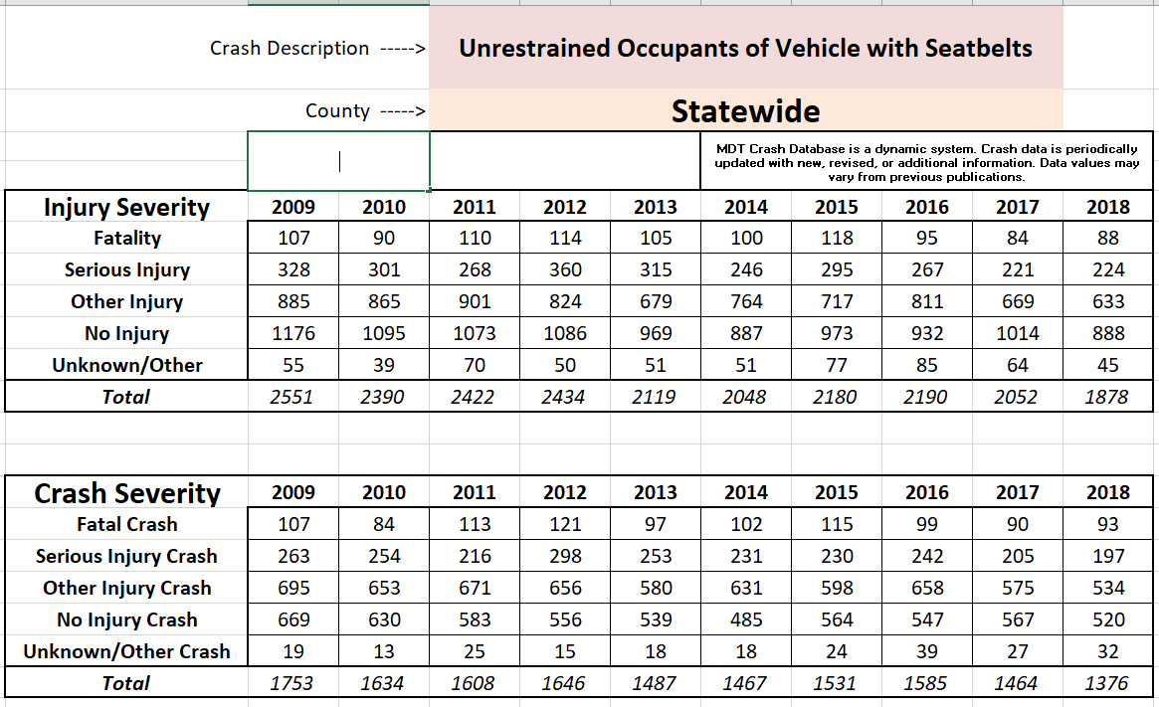

Park County Impaired Driving Charges and Convictions
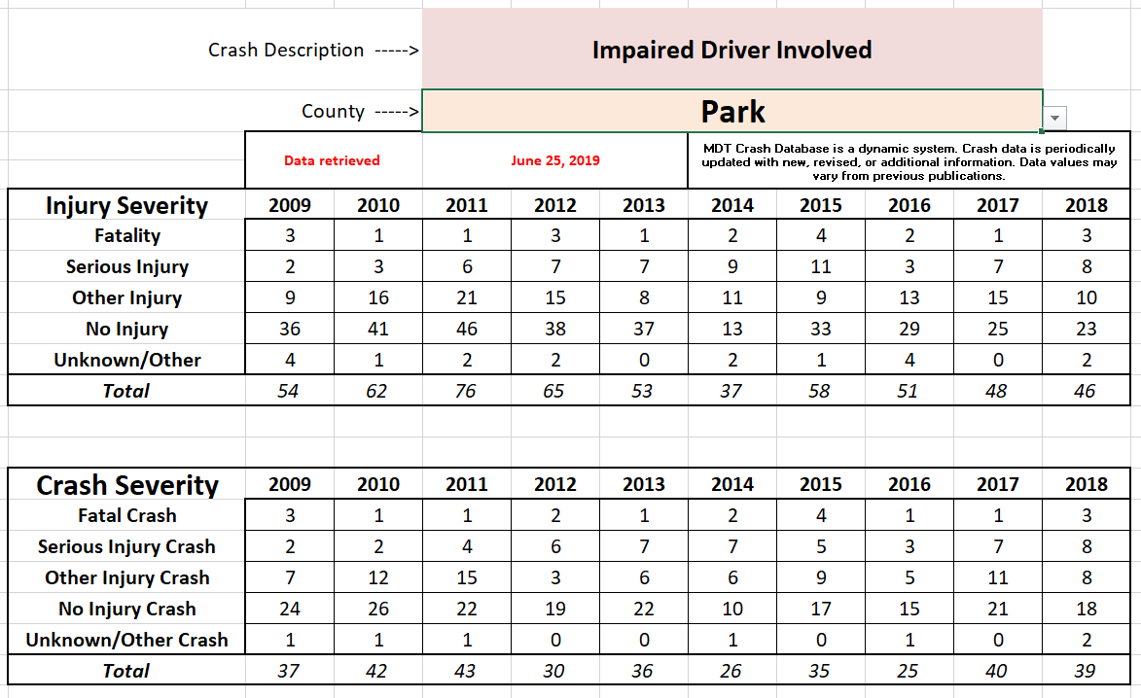

The Cost of Alcohol Abuse
Results of a study conducted by the University of Montana’s Bureau of Business and Economic Research, released in 2009, show that alcohol abuse costs the state's economy more than half a billion dollars per year in lost wages and productivity, alcohol treatment costs, medical costs, and other public and private spending
In 2016, the last year for which data were available, consumption of alcohol beverages in Montana equaled 3.11 gallons of ethanol per capita, more than 32 percent greater than the national average of 2.35 gallons per capita.
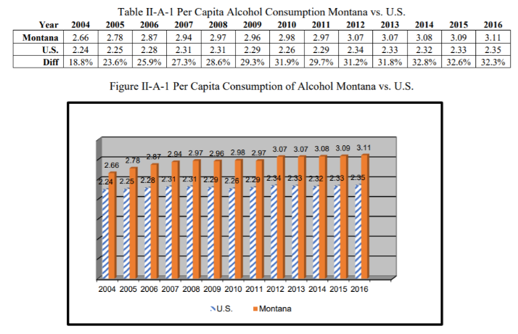

Montana’s DUI Task Forces

Montana currently has 36 recognized County Driving Under the Influence (DUI) Task Forces (DUITFs) representing 41 of the State’s 56 counties. DUI Task Forces were first formed in 1987, with the purpose of:
- preventing driving while under the influence of alcohol
- reducing alcohol-related traffic crashes
- educating the public on the dangers of driving after consuming alcoholic beverages or other chemical substances that impair judgment or motor functions.

Their work is governed by Sections 61-2-105 through 108 of the Montana Code Annotated.

DUI task forces are multi-faceted coalitions that invite participation from a cross-section of community representatives in order to maximize their reach and effectiveness. Initial funding comes from driver license reinstatement fees. The task forces operate at the county level to reduce and prevent impaired driving and may engage in a variety of activities. Many of the DUI Task Force members are volunteers who have a vested interest in the safety on our roadways.
Effective DUI task forces are an important mechanism for decreasing the state's alcohol-related injury and fatality rates.

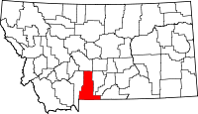

COUNTY OVERVIEW:
Park County
Park County rests in the south-central area of the state and borders Yellowstone National Park. It covers approximately 2,802 square miles according to the 2017 census Park County has an estimated population of about 16,353. To date, Park County has 90 liquor licenses.

According to the MDT’s crash data, Park Co. had 37 alcohol related crashes in 2014, with an up rise in 2015 with 58 alcohol related crashes, and a slight down fall in 2016 with 51 alcohol related crashes. According to Park County Justice Court there were 99 DUI citations issued in Park County from January 1, 2018 through December 31, 2018. Of the 308 citations issued, 278 were guilty, 2 were transferred to other courts, 3 were dismissed by the court and 2 were dismissed by the prosecution.

Impaired Driving Park County traffic crashes, arrests and Conviction

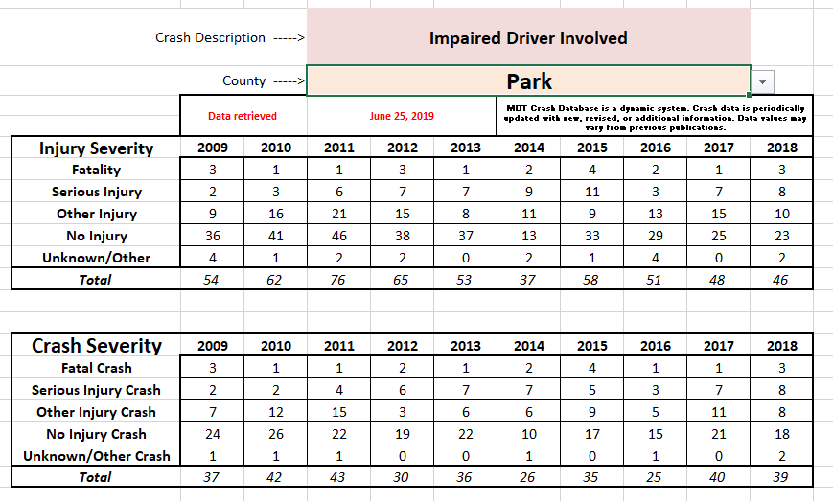

PARK COUNTY CONTINUES TO BE CHALLENGED WITH
- Illegal alcohol sales:
  - Over-service of alcohol to persons 21 and older
  - Sales to persons under 21 years of age
- Repeat DUI offenders
- Refusals to submit to breath/blood testing
- Minors in possession of alcohol (MIPs)
- Occupant safety and restraint issues related to impaired driving crashes

Progress has been made in the attempts to reduce alcohol related crashes in Park County. However, impaired drivers continue to pose a significant safety problem.

To enhance the effectiveness of Park County’s impaired and traffic safety programs in preventing injuries, saving lives, and reducing economic costs of motor vehicle crashes, this plan supports the priority recommendations of the State’s Impaired Driving Assessment conducted by the National Highway Traffic Safety Administration Technical Assistance Team on May 5-10, 2013 and the State’s Comprehensive Highway Safety Plan.

PROGRAM GOAL
The Park County DUI Task Force Strategic Plan for the period of July 1, 2020 through June 30, 2021 is to reduce the number of motorists who drive under the influence of alcohol or drugs and reduce traffic crashes, injuries, and fatalities in Park County by implementing the methods and strategies outlined below. This reduction will eliminate the economic costs associated with those crashes, injuries and fatalities. The task force will support evidence based programs and messaging to address safety and protection related to impaired driving.

PROGRAM ADMINISTRATION

DUI Task Force
The Park County DUI Task Force represents a diverse cross section of the community that includes citizens, government officials, law enforcement, business, health professionals, prevention and treatment specialists committed to reducing alcohol-related traffic crashes in Park County by implementing best practice traffic safety countermeasures. One of the more important activities of the Task Force is bringing various parties together to focus and coordinate efforts and acquire and share resources. The Park County DUI Task Force is committed to carry out the objectives set forth in this strategic plan for the period July 1, 2020 through June 30, 2021.

The Task Force works to:
- Keep our roads safe
- Prevent impaired driving
- Reduce alcohol-related traffic crashes
- Educate the public on the dangers of driving after consuming alcoholic beverages and/or other chemical substances that impair judgment or motor functions.
- Educate the public on the dangers of over-service
- Educate the public on the community corrosion that ensues with the accepted attitude of underage drinking.

Our members include:
- Law enforcement professionals
- Treatment and Prevention professionals
- Tobacco Use Prevention Program Coordinator (Park County Health Department)
- Juvenile probation
- Prosecuting attorneys
- Livingston Health Care professionals
- School Counselors and teachers

DUI Program Coordinator
A program responding to the many objectives and strategies contained in the Park County DUI Plans requires some expenditure for planning, coordination and administration.

The Park County DUI Task Force will provide monetary support for the DUI Task Force Coordinator as needed. The Task Force coordinator role will be funded for up to 5-10 hours per month ($180/mo.) as needed. Monies not drawn for coordinator wages will be left in task force account and be used for travel funds or an additional budget line item.

Administrative Costs for Lead Agency
The Park County Public Health Department is to act as the DUI Task Force lead agency for Park Co. Within this role, costs incurred include accounting by Park County Health Department, photocopier usage, fax machine, internet, and building maintenance costs ($300.00 annually).

The DUI Program Coordinator will be responsible for the following:
- Implement and monitor the Park County DUI Plan and budget
- Writing and submitting the Park County DUI Plan, and year-end report to both the Park County Commissioners
- Represent both Park County DUI Task Forces at the annual statewide DUI Task Force meeting
- Serve as the liaison to the media, the Montana Department of Transportation’s State Highway Traffic Safety Bureau and other community and state groups
- Administer DUI overtime contracts with local agencies (law enforcement)
- Look on horizon for potential funding streams/budget cuts and how to deal with cuts
Support Staff
- Provide administrative support for Task Force Coordinator, (e.g. Prepare meeting minutes for review, assist in quarterly meeting preparation).
- Assist committees in fulfillment of their goals and objectives
- Investigate additional funding resources
- Provide ongoing development and technical support to Task Force, under guidance of Task Force Coordinator

DUI Task Force Meeting Schedule
The Park County DUI Task Force meetings are open to the public. The Task Force’s goal is to meet on a quarterly basis; date of meeting depends on group availability.

The Park County DUI Task Force will advertise upcoming meetings in the community section of the Livingston Enterprise according to public notice requirements, 61-2-106(2), MCA.

TASK FORCE GOALS

1. Goal: Media Advocacy
Objective: Change permissive attitude toward buzzed driving through highly visible education and awareness campaigns.

Strategy: Create an environment where Park County residents think before they drink. Know the consequences of drinking and driving as well as selling/providing alcohol to minors (e.g. Have a transportation plan in place before they leave the home for a night out).

Methods: The Park County DUI Task Force will support programs and education that may include:
- High visibility messages such as billboards, posters, radio ads, press releases, newspaper articles, and movie theater clips. The task force will focus on high risk times throughout the remainder of FY 2020-2021 for proper placement of such media.
-Messages focus will be: underage drinking, over-service, impaired driving, personal responsibility, and alternative transportation options.
- Educational programs such as RASS training, classroom traffic safety presentations, etc.
-Place ad in local newspaper advertising upcoming Let’s Control it trainings. Send out postcards to all liquor license holders in Park County announcing meeting date, time, and location for upcoming Let’s Control it trainings.
- Collaboration with the local media outlets to provide current traffic safety statistics regarding impaired driving arrests, crashes, and adjudication.
-E.g. Place in local newspaper regarding the number of DUI fatalities per year in MT, Park Co. Highlight upcoming holidays in paper with stay safe messages, and traffic fatalities.

Timeline: Upon approval of plan through June 30, 2021.

2. Goal: Law Enforcement Support-High Visibility Enforcement

Objective: Support local Law Enforcement through collaboration and financial support.

Strategy: Encourage open-dialog between Task Force and Law Enforcement to discuss community needs and gaps in services.

Methods: The Park County DUI Task Force will support prosecution and law enforcement through programs and training that may include:
- Providing funds for DUI processing supplies such as straws, test kits, water bottles, etc.
- Partner with local LE, judges, chemical dependency service providers and probation.
- Provide OT wages for officers working HV Enforcement as well as provide accompanying media campaign to support the extra police presence.
- Supporting DUI-Specific training for Law Enforcement that could include but not limited to: one, two, or five-day Standard Field Sobriety Testing (SFST) recertification, two-day Advanced Roadside Impaired Driving Enforcement (ARIDE), and/or Drug Recognition Expert (DRE).
- Provide funds for Prosecuting DUI training for prosecuting attorneys.
- Provide funding and support for Compliance Checks.

Timeline: Upon request through June 30, 2021
.
3. Goal: Underage Drinking Prevention

Objective: Reduce drug and alcohol impaired driving incidents and minor in possessions through supporting youth projects, compliance checks, and sponsoring youth activities.

Strategy: Increase awareness of the dangers of underage drinking and impaired driving.

Methods: The Park County DUI Task Force will support underage drinking prevention through programs and education that may include:
- Prime for Life (Teens) in partnership with Park County Juvenile Probation.
Taught by Julie Anderson, certified Prime for Life instructor.
- Court-ordered educational classes for Park County youth receiving Minor in Possession charges. In partnership with Park High School Resource Officer, Juvenile Probation and the Park County Health Department.
- Monetary support for sponsorship of youth functions
- Use funds to continue to conduct alcohol compliance checks

Timeline: Upon approval of plan through June 30, 2021

4. Goal: Responsible Alcohol Server’s (RASS) Training

Objective: Continue to provide Let’s Control it trainings once per month in Livingston and as needed in surrounding count areas.

Strategy: Continue to hold one RASS training per month. Offer on-site trainings for establishments. Target merchants that fail compliance checks to see if all employees training certificates are up-to-date and comply with state regulations. Provide training times by sending DUI Task Force post cards announcing training dates, location, time, etc.

Methods: Support local RASS trainings by providing recognition and incentives for proactive licensed establishments. Examples may include:
- Offer Task Force purchased ID scanner for use to RASS trained establishments
- Provide incentives for establishments that send employees to training (e.g. ID checking guides, 3M laminate verifiers, etc.)
- Offer in-house RASS trainings

Timeline: Upon approval of plan through June 30, 2021
.
5. Goal: Bar Checks for Over-service

Objective: Create awareness of over-service by educating tavern managers, owners, and employees about the dangers of over-service and how that could severely impact their lives. Partner with local law enforcement to try and establish over-service bar checks. Raise public awareness surrounding over-service through media advocacy campaigns.

Strategy: Increase community awareness surrounding over-service of alcohol by partnering with local law enforcement and the local newspaper (by publishing results of checks).

Methods: The Park County DUI Task Force will support bar checks for over-service, this may include:
- Partnering with law enforcement to conduct checks/issue citations throughout Park County.
- Employing media advocacy to promote responsible drinking
- Promoting public education through the media about the harmful effects of drink specials that promote over-consumption

Timeline: Upon approval of plan through June 30, 2021

6. Goal: Additional Funding

Objective: Seek grants and additional funding to add to the monies received from Park County reinstatement fees.

Strategy: Enhance the Park County DUI Task Force ability to continually support community programs as well as law enforcement and prosecution.

Methods: The Park County DUI Task Force will make an effort to consistently look for additional funding, this may include:
- Seeking funding from government entities
- Contacting local businesses to inquire about matching funds or in-kind donations
- Developing a system for donations

Timeline: Upon approval of plan through June 30, 2021

Evaluation

Each of the objectives in the plan will be monitored and measured as follows:

- Media Advocacy
  - Number of billboards, posters, radio ads, press releases, newspaper articles and movie theater clips
  - Number and type of educational programs provided.
  - Identify average listenership/readership reach of newspapers, radio and billboard advertisements
  - Number of student/community members engaged within each program
  - Number of community members attending such speaking engagements

- Law Enforcement Support-High Visibility Enforcement
- Amount of funds paid out to officers for processing supplies and description of items purchased
- Number of/and types of trainings provided for officers and prosecution
- Number of OT hours paid for high visibility enforcement
- Number of DUI arrests made
- Results of bar checks for over-service

- Underage Drinking Prevention
  - Number youth prevention activities held and/or sponsored, synopsis of event
  - Track number of MIPs issued from this year compared to last
  - Outcome evaluations will be developed for specific programs developed and implemented
  - Number of compliance checks conducted. Compliance rate for checks.

- Let’s Control It Training
  - Number of participants who attend Responsible Alcohol Sales/Service training
  - Increase number of establishments participating in RASS trainings per year.
  - Types of incentives given to establishments sending employees to RASS.

- Bar Checks for Over-service
- Number of checks conducted
- Number citations issued, number reported to MDOR
- Examples of media coverage surrounding over-service checks

- Additional Funding
  - Amount and sources of additional funding obtained, projects funded

Impact Evaluation will be conducted focusing upon the following items tracked by the DUI Research Project in Park County:

- Reduce incidents of impaired driving as evidenced by a reduction in DUI arrests in Park County
- Reduce incidents of injuries sustained in alcohol or other drug related accidents in Park County
- Reduce the number of DUI related deaths in Park County

Additionally, to measure program progress we will look at the following:

  - Youth Risk Behavior Survey (YRBS) and the Prevention Needs Assessment Survey (PNA) on teen 30-day use and sources of obtaining alcohol
  - Analyze crash data from Montana Department of Transportation to determine trends.
FY 2020 Park County DUI Plan
June 1, 2020-June 30, 2021
Estimated BUDGET

Revenue
Cash on hand. Balance of revenue account, which will be rolled over to Fiscal Year 2020 | $ 5,000.00
Estimated DUI Reinstatement Fees for FY2020 | $ 6,000.00
Total projected revenue | $ 11,000.00
Expenses
Administration
1) Office Supplies & Equipment | $ 500.00
2) DUI Task Force Administration Fees | $ 2160.00
Enforcement, Prosecution, Adjudication
1) DUI Processing Supplies/Equipment | $ 1,000.00
3) Training | $ 500.00
4) Compliance checks | $ 500.00
Education/Awareness/Prevention
2) RASS Classes | $ 500.00
3) Educational Supplies | $ 200.00
4) Paid media | $ 1,000.00
5) Educational speaker/lessons for schools | $ 1,500.00
Total Expenses | $ 7,860.00
Total estimated revenue for FY20 | $ 11,000.00
Total estimated expenses for FY20 | $ 7,860.00
Balance and planned carry forward to FY20 | $3,140.00
Budget Narrative
The budget below includes rollover funds from previous fiscal years. It also includes an estimated amount of reinstatement fees and donations. This budget is subject to change due to the variations of funds received. Projected expenditures align with strategies discussed above

