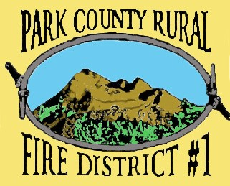
“Dedicated to Serving with Integrity, Leadership, and Compassion.”
It is the Mission of Park County Rural Fire District #1 to protect life and prevent loss to property within the District. We will accomplish this Mission in an economical and professional manner, through high quality emergency response and progressive training and education, and will strive to create alliances with our community and other emergency agencies.

PARK COUNTY RURAL FIRE DISTRICT #1
REGULAR BOARD MEETING AGENDA OCTOBER 9, 2023
TIME: 6:00 P.M.
LOCATION: 304 EAST PARK STREET LIVINGSTON, MT
- CALL MEETING TO ORDER
- PUBLIC COMMENT—
- APPROVE MINUTES FROM SEPTEMBER, 2023 MEETINGS (Ref 1)
- REVIEW CLAIMS AND WARRANTS
- FINANCIAL REPORT AUGUST (Ref 2)
- FIRE CHIEFS REPORT FOR SEPTEMBER (Ref 3)
- OLD BUSINESS

DISCUSSION/DECISION KOA SIGNAGE
DISCUSSION/DECISION DNRC CONTRACT
DISCUSSION/DECISION OK2 LEASE STATION 3
DISCUSSION/DECISION STATION 3 PROJECT COMPLETION

- NEW BUSINESS
DISCUSSION DECISION RESOLUTION 23-01 RADIO REPEATER USAGE FOR FIRE DISPATCH
DISCUSSION/DECISION of WINTER FREEWAY CLOSURE.
PUBLIC COMMENT

- ADJOURNMENT

